1.42: a) The x- and y-components of the sum are 1.30 cm + 4.10 cm = 5.40 cm,
2.25 cm + (–3.75 cm) = –1.50 cm.

- Using Equations (1-8) and (1-9),

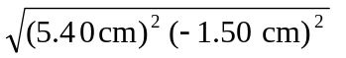= 5.60 cm, arctan 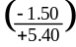 = 344.5º ccw.

- Similarly, 4.10 cm – (1.30 cm) = 2.80 cm, –3.75 cm – (2.25 cm) = –6.00 cm.

d) 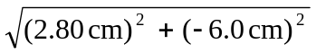 = 6.62 cm, arctan 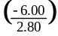 = 295º (which is 360º – 65º).

